

NAIROBI SCHOOL 2025 PREDICTION
KCSE ANTICIPATION EXAM
233/2
CHEMISTRY
PAPER 2 (THEORY)
TIME: 2 HOURS

NAME……………………………………………………………………………………….
SCHOOL……………………………………………… SIGN………………………..
INDEX NO……………………………………………. ADM NO……………………

(Kenya Certificate of Secondary Education)

INSTRUCTIONS TO CANDIDATES
- Write your name and index number in the spaces provided above.
- Sign and write the date of examination in the spaces provided above.
- Answer all the questions in the spaces provided.
- Mathematical tables and silent electronic calculators may be used.
- All working must be clearly shown where necessary.

FOR EXAMINER’S USE ONLY
QUESTION | MAXIMUM SCORE | CANDIDATE’S SCORE
1 | 11
2 | 12
3 | 12
4 | 11
5 | 11
6 | 12
7 | 11
Total score | 80

- The diagram below shows the apparatus for the preparation of gas A and investigate on its properties. Study it and answer the questions that follow.
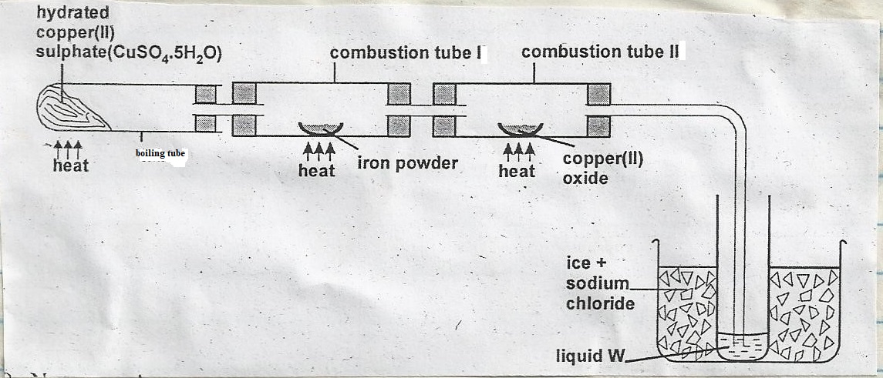
  - (i) Name gas A. (1mark)
………………………………………………………………………………………………………
(ii)Suggest the property of gas A under investigation. (1mark)
………………………………………………………………………………………………………

(iii) Write chemical equations for the reactions in the;
Boiling tube (1 mark)
………………………………………………………………………………………………………

Combustion tube I (1 mark)
………………………………………………………………………………………………………

  - State and explain the observation made in
(i) Boiling tube. (1mark)
………………………………………………………………………………………………………
………………………………………………………………………………………………………

(ii) Combustion tube II. (1mark)
………………………………………………………………………………………………………
………………………………………………………………………………………………………

  - What is the use of hydrated copper (II) sulphate in the experiment? (1mark)
………………………………………………………………………………………………………
………………………………………………………………………………………………………

d) (i) Name one other substance that comes out of tube II. (1mark)
………………………………………………………………………………………………………

(ii) Name liquid W. (1mark)
………………………………………………………………………………………………………

(iii) What is the role of sodium chloride in the ice (freezing mixture). (1mark)
………………………………………………………………………………………………………
………………………………………………………………………………………………………

(iv) Explain why hydrogen gas has been replaced by helium in filling of aereoplane tyres.
(1mark)
………………………………………………………………………………………………………
………………………………………………………………………………………………………

2.(a) Study the flow chart below and answer the questions that follow.
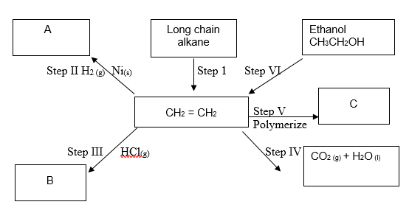
- Name the process-taking place in step I. (1mark)
………………………………………………………………………………………………………

Describe a chemical test that can be carried out determine the identity of organic compound A.
(2marks)
………………………………………………………………………………………………………
………………………………………………………………………………………………………
………………………………………………………………………………………………………

Give the name of the following: (2marks)
  - A……………………………………………………………………..
  - B……………………………………………………………………..

- Give the structural formulae of substance C. (1mark)
………………………………………………………………………………………………………
………………………………………………………………………………………………………
………………………………………………………………………………………………………

- Name the type of reaction that occurs in:
  - Step IV . (2marks)
………………………………………………………………………………………………………
  - Step VI:
………………………………………………………………………………………………………

- Give the reagent and the condition necessary for step VI. (2marks)
Reagent……………………………………………………………………………………
Condition…………………………………………………………………………………

- Give the systematic names of the following compounds:
  - CH₃CHCHCH₂CH₃ (1mark)
………………………………………………………………………………………………………

  - CHCCH₃ (1mark)
………………………………………………………………………………………………………

3. The grid below forms part of the periodic table. Study it and answer the questions that follow. The letters do not represent the actual symbols of the elements.
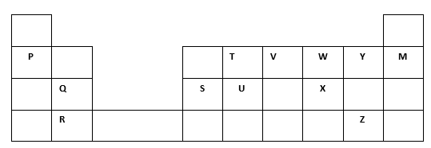
- Write the general name given to the group where element P belong. (1mark)
………………………………………………………………………………………………………
b) An element N has an atomic number of 15. Write down its electronic arrangement and hence fix it in its right position on the grid above. (2marks)
Electronic arrangement
………………………………………………………………………………………………………
………………………………………………………………………………………………………
………………………………………………………………………………………………………

- Compare the size of the atom of R and that of its ion. Explain your answer. (2marks)
………………………………………………………………………………………………………
………………………………………………………………………………………………………
………………………………………………………………………………………………………

c) Give the formula of the compound formed between. (1mark)
- P and W
………………………………………………………………………………………………………

- T and Y
………………………………………………………………………………………………………

e) Compare the melting points of element Q and S. Explain. (2marks)
………………………………………………………………………………………………………
………………………………………………………………………………………………………
………………………………………………………………………………………………………
………………………………………………………………………………………………………

- State the most reactive non-metal from the grid. Give a reason for your answer. (2marks)
………………………………………………………………………………………………………
………………………………………………………………………………………………………
………………………………………………………………………………………………………

- Write chemical equations for the thermal decomposition of nitrates of: (2marks)
- Q
………………………………………………………………………………………………………

ii) P
………………………………………………………………………………………………………

4. a) The results below were obtained in an experiment conducted by form three students from Isaboke secondary school using magnesium.
- Mass of the crucible + lid = 19.52g
- Mass of the crucible + lid + Magnesium Ribbon = 20.36g
- Mass of the crucible + lid + Magnesium oxide = 20.92g
(i) Use the results to find the percentage mass of Magnesium and Oxygen in magnesium oxide.
(2marks)
………………………………………………………………………………………………………
………………………………………………………………………………………………………
………………………………………………………………………………………………………
………………………………………………………………………………………………………
………………………………………………………………………………………………………

(ii) Determine the empirical formula of magnesium oxide. (Mg=24.0, O=16.0) (2marks)
………………………………………………………………………………………………………
………………………………………………………………………………………………………
………………………………………………………………………………………………………
………………………………………………………………………………………………………

b) Sodium hydroxide pellets were accidentally mixed with sodium chloride. 8.8g of the mixture were dissolved in water to make one litre of solution. 50cm³ of the solution was neutralised by 20cm³ of 0.25M sulphuric acid.
(i) Write an equation for the reaction that took place. (1mark)
………………………………………………………………………………………………………
(ii) Calculate the:
- Number of moles of the substance that reacted with sulphuric acid. (2marks)
………………………………………………………………………………………………………
………………………………………………………………………………………………………
………………………………………………………………………………………………………
………………………………………………………………………………………………………

II. Number moles of the substance that would react with sulphuric acid in the one litre solution.
(1mark)
………………………………………………………………………………………………………
………………………………………………………………………………………………………
………………………………………………………………………………………………………

III. The percentage of sodium chloride in the mixture. (3marks)
(H=1.0; Na=23.0; Cl=35.5; O=16.0)
………………………………………………………………………………………………………
………………………………………………………………………………………………………
………………………………………………………………………………………………………
………………………………………………………………………………………………………
………………………………………………………………………………………………………

5. The set-up below can be used to generate a gas.
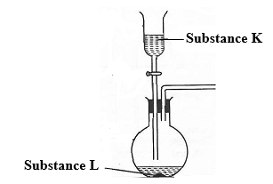
(a) (i) Complete the table below giving the names of substance K and L if the gases generated are carbon (IV) oxide and carbon (II) oxide. (2marks)
Substance | Carbon (IV) oxide | Carbon (II) oxide
K
L
(ii) Complete the diagram to show how a sample of carbon (II) oxide can be collected. (2marks)
(iii) State two ways that can be used to distinguish carbon (IV) oxide from carbon (II) oxide? (2marks)
………………………………………………………………………………………………………
………………………………………………………………………………………………………
………………………………………………………………………………………………………

(b) (i) In an experiment, carbon (IV) oxide gas was passed over heated charcoal held in a combustion tube. Write a chemical equation for the reaction that took place in the combustion tube. (1mark)
………………………………………………………………………………………………………
………………………………………………………………………………………………………
(ii) State one use of carbon (II) oxide. (1mark)
………………………………………………………………………………………………………
………………………………………………………………………………………………………

(c) The following set ups were used by Form Two students. Study and use them to answer the questions that follow.
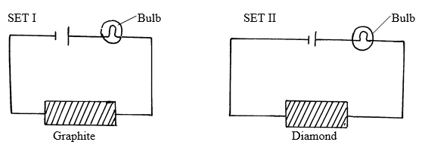

State and explain the observations made in set up I and II above. (3marks)
………………………………………………………………………………………………………
………………………………………………………………………………………………………
………………………………………………………………………………………………………
………………………………………………………………………………………………………
………………………………………………………………………………………………………

6. a) The set up below was used during electrolysis of aqueous copper (II) sulphate using inert electrodes.
Aqueous copper (II) Sulphate
- Name a suitable pair of electrodes for this experiment. (1 mark)
………………………………………………………………………………………………………

- Write formula of the anions and cations in the solution. (1 mark)
………………………………………………………………………………………………………
………………………………………………………………………………………………………

- On the diagram, label the cathode. ( 1mark)
- Write ionic equation for the reaction that took place at the anode. (1 mark)
………………………………………………………………………………………………………

- Explain the observation that occurred to the Copper (II) Sulphate solution during the experiment. (2 marks)
………………………………………………………………………………………………………
………………………………………………………………………………………………………
………………………………………………………………………………………………………

- During the electrolysis, a current of 2 amperes was passed through the solution for 4 hours. Calculate the volume of the gas produced at the anode. (1 Faraday = 96,500 coulomb. Volume of gas at room temperature = 24,000cm³). (3 marks)
………………………………………………………………………………………………………
………………………………………………………………………………………………………
………………………………………………………………………………………………………
………………………………………………………………………………………………………
………………………………………………………………………………………………………

b) i) Draw a diagram to show how an impure copper lump can be refined through electrolysis. (2marks)

ii) State one other application of electrolysis other than the one shown in b (i) above. (1mark)
………………………………………………………………………………………………………
………………………………………………………………………………………………………

7. (a)The solubilities of potassium nitrate and potassium bromide at different temperatures were determined. The following data was obtained.
Temperature ⁰C |  | 0 | 10 | 20 | 30 | 40 | 50 | 60 | 70 | 80
Solubility g/100g H₂O | KNO₃ | 5 | 15 | 26 | 43 | 61 | 83 | 105 | 135 | 165
 | KBr | 50 | 55 | 60 | 65 | 70 | 77 | 85 | 90 | 95

(i) Draw solubility curves for both salts on the same axis. (3marks)


(ii) What was the solubility of each salt at 65⁰C? (1mark)
………………………………………………………………………………………………………
………………………………………………………………………………………………………

(iii) 100g of a saturated solution of potassium nitrate at 75⁰C was cooled to 25⁰C. What mass of the crystals will be formed? (3marks)
………………………………………………………………………………………………………
………………………………………………………………………………………………………
………………………………………………………………………………………………………
………………………………………………………………………………………………………

(b) Study the flow chart below and answer the questions that follow
Metal carbonate
Heat
Solid A
+
Gas B
Dilute HCl
Solution
C
Deep blue solution E
Solid D
A few drops of NH_{3 (aq)}
Excess of
NH_{3 (aq)}
(i)Write an equation for the formation of solid A and gas B. (1mark)
………………………………………………………………………………………………………
………………………………………………………………………………………………………

(ii)Name;
Solution C ………………………………………………………………. (1mark)
Solid D …..……………………………………………………………… (1mark)

(c)Write the formula of the complex ion in solution E. (1mark)
………………………………………………………………………………………………………
………………………………………………………………………………………………………

THIS IS THE LAST PTINTED PAGE

